**You2.0 – Beyond Tracking, Into Becoming**

A major project report submitted in partial fulfillment of the requirement for the award of degree of

**Bachelor of Technology**

in

**Computer Science & Engineering**

*Submitted by*

**Aashi Gupta (221030140)**

**Ishleen Kaur (221030249)**

**Lakshay Malik (221030022)**

*Under the guidance & supervision of*

**Mr. Kuntal Sarkar**



**Department of Computer Science & Engineering and**

**Information Technology**

**Jaypee University of Information Technology, Waknaghat, Solan - 173234 (India)**

**December 2025**

**Table of Content**

|  |  |
| --- | --- |
| **Title** | **Pg No** |
| **Declaration** | **i** |
| **Certificate** | **ii** |
| **Acknowledgement** | **iii** |
| **List of Figures** | **iv** |
| **Abstract** | **v-vi** |
| **Chapter-1:Introduction** | **1-4** |
| **Chapter-2 : Literature Survey** | **4-11** |
| **Chapter-3 : System Development** | **12-26** |
| **Chapter-4: Testing** | **27-30** |
| **Chapter-5: Results and Evaluation** | **31-37** |
| **Chapter-6: Conclusion and Future Scope** | **38-39** |
| **References** | **30-42** |

**Candidate’s Declaration**

We hereby declare that the work presented in this major project report entitled ‘**You2.0 – Beyond Tracking, Into Becoming**’, submitted in partial fulfillment of the requirements for the award of the degree of **Bachelor of Technology in Computer Science & Engineering**, in the Department of Computer Science & Engineering and Information Technology, Jaypee University of Information Technology, Waknaghat, is an authentic record of our own work carried out during the period from July 2025 to December 2025 under the supervision of **Mr. Kuntal Sarkar.**

We further declare that the matter embodied in this report has not been submitted for the award of any other degree or diploma at any other university or institution.

Name & Sign: Aashi Gupta Name & Sign: Lakshay Malik

Roll No.: 221030140 Roll No.: 221030022

Date: 29th November 2025 Date: 29th November 2025

Name & Sign: Ishleen Kaur

Roll No.: 221030249

Date: 29th November 2025

This is to certify that the above statement made by the candidates is true to the best of my knowledge.

Date: 29th November 2025 Supervisor Name & Sign: Mr. Kuntal Sarkar

Place: JUIT Designation: Assistant Professor

Department: CSE

**Supervisor’s Certificate**

This is to certify that the major project report entitled ‘**You2.0 – Beyond Tracking, Into Becoming’,** submitted in partial fulfillment of the requirements for the award of the degree of Bachelor of Technology in Computer Science & Engineering, in the Department of Computer Science & Engineering and Information Technology, Jaypee University of Information Technology, Waknaghat, is a bonafide project work carried out under my supervision during the period from July 2025 to December 2025. I have personally supervised the research work and confirm that it meets the standards required for submission. The project work has been conducted in accordance with ethical guidelines, and the matter embodied in the report has not been submitted elsewhere for the award of any other degree or diploma.

Date: 29th November 2025 Supervisor Name & Sign: Mr. Kuntal Sarkar

Place: JUIT Designation: Assistant Professor

Department: CSE

**Acknowledgement**

Firstly, I express my heartiest thanks and gratefulness to almighty God for His divine blessing makes it possible for us to complete the project work successfully.

I am really grateful and wish my profound indebtedness to Supervisor  **Mr. Kuntal Sarkar**, **Assistant Professor,** Department of CSE Jaypee University of Information Technology,Wakhnaghat. Deep Knowledge & keen interest of my supervisor in the field of “Machine Learning” to carry out this project. Her endless patience, scholarly guidance, continual encouragement, constant and energetic supervision, constructive criticism, valuable advice, reading many inferior drafts and correcting them at all stages have made it possible to complete this project.

I would like to express my heartiest gratitude to  **Mr. Kuntal Sarkar**, Assistant Professor, Department of CSE, for his kind help to finish my project.

I would also generously welcome each one of those individuals who have helped me straightforwardly or in a roundabout way in making this project a win. In this unique situation, I might want to thank the various staff individuals, both educating and non-instructing, which have developed their convenient help and facilitated my undertaking.

Finally, I must acknowledge with due respect the constant support and patience of my parents.

**Aashi Gupta (221030140)**

**Ishleen Kaur (221030249)**

**Lakshay Malik (221030022)**

# 

# 

# **List of Figures**

|  |  |  |
| --- | --- | --- |
| **Figure Number** | **Figure Title** | **Page Number** |
| **Figure 3.2.1** | **Design and Architecture** | **13** |
| **Figure 5.1.2** | **Sample Training Images from the Food-101 and Indian Food Dataset** | **32** |
| **Figure 5.1.3** | **Sample Prediction Outputs from the Trained Food Classification Model showing confidence scores** | **32** |
| **Figure 5.1.4** | **Terminal Snapshot Showing Model Output and Inference Results.** | **33** |
| **Figure 5.1.5** | **Screenshot Showing Food Dataset Labels and category structure used for training.** | **33** |
| **Figure 5.1.6** | **Classification Report Showing Precision, Recall, F1-Score** | **34** |
| **Figure 5.1.7** | **Confusion matrix and Heatmap** | **34** |
| **Figure 5.1.8** | **ROC Curve** | **35** |

**Abstract**

The current generation residing in the modern world is more prone to unhealthy lifestyle due to many reasons such as the absence of sleep cycles, bad eating habits, sitting too much, and poor physical exercises[1]. All these are leading to the evolution of non-communicable illnesses such as obesity, diabetes, high blood pressure and chronic stress that have been listed as the foremost health challenges in the entire world today[2]. According to the research conducted by WHO, the noncommunicable diseases caused by unhealthy lifestyle choices result in the death of a large number of premature deaths annually, and the trend of a steady increase in the number is persisting[3]. Although, nowadays, people know more about health and fitness, they do not continue to analyze and re-analyze their everyday routines very frequently. The consumption of water, sleep conditions and passive time are already considered complex activities, thereby triggering challenging health problems that could have been resolved at an early age. The available products most of the fitness plans and wearables can offer today are simply capable of being partial solutions since they handle a particular detail, such as the amount of steps or heart rate, give vague recommendations, or are simply too costly to be viable to students and workers who need inexpensive, yet holistic tools. It has a fully smart system that does not only calculate numerous factors of lifestyle, but also in response to the behavior of the user, provides relevant, personal information.

To seal this gap, it is proposed in the initiative that an AI-Powered Lifestyle and Wellness Tracker, a technologically advanced health companion, is developed that collects, processes, and analyzes user data in meaningful ways. The arrangement will use both manual recording (diet, hydration and mood) and sensor recording (sleep, activity and inactivity) to develop a detailed picture of the day-to-day life of a person. The application will show the trends in the health of the user and will also be able to predict and warn the user of possible health concerns, and lastly, make personalized recommendations that will help to mitigate the risk of being affected by health problems due to the lifestyle that the user has led, because of the use of machine learning models, which have been trained on real health statistics[14]. As an example, the system will notify users of the risk of obesity in case the combination of sedentary activity, poor nutrition, and at the same time, one will be reminded with the help of the interactive, gamified features of tracking habits, which will make the users pay attention to their sleep data, which has been below its recommended state quite some time. Aids such as You are two hours inactive - take a short walk or Your water consumption today is below normal - have a glass of water can get you through the day in a healthy manner. The overall aim of the project is to unite the AI-based predictions with the communicative feedback and the progress tracking with the goal of promoting the health management, lifestyle improvement and the year-long habit formation. Finally, it demonstrates the possibilities of technology as a preventive tool of the reduction of lifestyle diseases and not a reactive tool.

**Chapter 01: Introduction**

**1.1 Introduction**

The current busy lifestyle has led to a lack of ability to live a healthy lifestyle as people experience poor sleeping habits, poor diet, too much time at the computer, too much inactivity among others. The factors are significant in the lifestyle diseases like obesity, diabetes, hypertension and chronic stress that have become one of the gravest health challenges across the globe[1][2]. World Health Organization study found that noncommunicable diseases that are a result of a bad lifestyle take up a substantial portion of premature deaths annually and this trend is continually rising[3]. Although, people have become more learned, the majority of them do not always scrutinize and revisit their daily habits. Basic activities like monitoring water usage, sleep patterns, and time spent idly are usually neglected and eventually lead to health complications that could have been avoided when treatment is done at the initial stage. Although the current fitness apps and wearables present some solutions, some of them target some of their features like the number of steps or heart rate, others provide too broad recommendations, and some are too costly to be affordable and offer comprehensive options to students and professionals who need budget-friendly and effective solutions. The missing component is an intelligent wholesome system that does not just analyze various aspects of a lifestyle but also learns the user behavior to give valuable and personalized information[5].

In order to fill this gap, the offered project proposes an AI-Powered Lifestyle and Wellness Tracker[6], a smart health companion that gathers, analyzes, and interprets the data received by users in productive manners. The system will be based on manual (meals, hydration, mood) and sensor-based (sleep, activity, and inactivity) logging to provide a complete overview of the daily routine of a person. The application will use machine learning models that were trained on actual health statistics[18] of the population to detect trends, potential hazards, and provide specific recommendations to reduce the chances of contracting lifestyle diseases. As an instance, the system might be able to convey the dangers of obesity, in case prolonged sitting and poor nutrition are detected, or remind users of stress and exhaustion, in the case the sleep data is consistently lower than recommended.This solution will use real-time customized notifications and gamified habit tracking to engage the user. You could be advised by such things like, You have not taken a stroll in two hours - go and take a brisk walk or Your daily water consumption is below average - drink one glass of water to keep you healthy throughout the day. The project aims to assist individuals in controlling their health, adjusting their lifestyle, and establishing long-term practices with integrating AI-driven predictions alongside stimulating feedback and tracking their progress. Lastly, it shows how technology may be applied as a proactive means of minimizing lifestyle disorder.

A good balance is something the majority of us struggle to achieve in the modern busy world; unhealthy eating, sitting too long, and sleep disorders as well as constant stress are all the order of the day. These behaviors are closely connected with obesity, diabetes, and hypertension that today are among the largest global health issues. Despite the existence of fitness devices and applications, they are often lacking - either focusing more on the heart rate or steps, giving general tips, or being too costly. Our project fills that need. The Lifestyle and Wellness Tracker You2.0: Beyond Tracking, Into Becoming is a product that is supposed to be more than a mere monitoring tool, run by AI. Once it has developed a holistic image of daily events by means of human logging and sensor-based monitoring, it uses machine learning to detect any hazards and offer personalized and real-time advice. By providing such features as proactive health insights, habit tracking, and intelligent reminders, You2.0 aims to help users in changing their lifestyles instead of tracking them.

### **1.2 Problem Statement**

Lifestyle diseases that have risen globally due to modern lifestyles, which include insufficient sleep, poor diet, increased sedentary lifestyles, and lack of physical exercises are associated with poor lifestyles life, exemplified by such lifestyle diseases that include obesity, diabetes, hypertension, stress, among others. Although people are more aware of their daily activities, most of them do not weaken efforts to ensure that they look into their activities on a daily basis, leading to avoidable health issues. Current solutions like fitness applications and wearables are either incomplete, not customised or too costly to work and students. It is evident that there is a requirement of an easily accessible and smart system that would combine a large number of lifestyle indicators, interpret patterns, and give real-time specific and actionable feedback.

**1.3 Objective**

* To create a system that records lifestyle data (diet, sleep, physical activity, hydration, and mood) either manually or through sensors.
* To generate and apply machine learning models, who will evaluate data and predict any possible health risks (obesity, stress, diabetes).
* To provide personalized and real-time recommendations and gamified habit-tracking to promote healthy habits.
* To incorporate customized alerts and reminders that encourage people to make better choices all day long.
* To present an easy to use mobile experience that will make tracking, data entry and visualization enjoyable and simple.
* To provide reference reports weekly or monthly to the consumer with trends analysis and data-driven information to enable them identify long-term trends in their lifestyle.

### **1.4 Significance and Motivation of the Project Work**

Globally, lifestyle-related diseases are considered to be among the leading causes of premature mortality that incurs a significant percentage of medical expenses[3]. Such a little daily routine like drinking water or taking inactive breaks can make a lot of difference in the long-term health but are often ignored. Existing applications have minimal features[15] (step count) and cannot offer detailed and personalized information.

This program is fueled by the wish to empower individuals to ensure that they are in control of their own health in a proactive, affordable as well as fun manner.

* It is proposed that AI-based analysis with real-time cues and gamification will be used to manage the risk of lifestyle diseases[9][25].
* Promote better health through daily feedback.
* Provide wellness management to students, young professionals, and the general population.

Lastly, this paper demonstrates how technology can be used in moving beyond passive tracking to the active and intelligent coaching of long-term improvement of health.

**1.5 Organization of Project Report**

The rest of the report is organized as follows:

* **Chapter 02: Literature Survey** provides the map of the present literature, the major results, and the gaps on the research fields in the sphere of digital wellness and self-management applications.
* **Chapter 03: System Development** provides the details of the implementation process, which included system requirements, tools and datasets selection, the overall design, and the computational models that were created.
* **Chapter 04: Testing** explains the process and conditions of testing the functions and performance of the system.
* **Chapter 05: Results and Evaluation** shows the results of the testing stage, as well as the performance indicators and analysis of the developed components.
* **Chapter 06: Introduction and Future Scope** concludes the project and proposes the future directions of work and improvements.
* **Lastly,** the **References** section contains all the research papers and external sources used during this work.

**Chapter 02:Literature Survey**

**2.1 Literature Overview**

|  |  |  |  |  |  |
| --- | --- | --- | --- | --- | --- |
| S. No. | Author &  Paper Title  [Citation] | Journal/  Conference (Year) | Tools/  Techniques/  Dataset | Key Findings/  Results | Limitations/  Gaps Identified |
| 1. | Chiam et al. – Co-Pilot for Health Personalized Algorithmic AI Nudging to Improve Health Outcomes[1] | BMJ Open | Wearables + AI nudging system; large-scale intervention (84,764 participants) | Increased daily steps by ~6.17% and MVPA by ~7.61% with AI nudges vs control | Limited to physical activity outcomes; does not cover diet, stress, or holistic wellness |
| 2. | JMIR Cardio – AI-Based, Autonomous, Digital Health Intervention Using Precise Lifestyle Guidance on Blood Pressure in Adults With Hypertension[2] | JMIR Cardio (2024) | BP monitor + wearable tracker + questionnaires + personalized ML models | Improved blood pressure control using AI-driven personalized guidance | .Non-randomized single-arm trial; results may lack generalizability |
| 3. | Stolfi et al. – Use of Non-Invasive Parameters and Machine Learning Algorithms for Predicting Future Risk of Type 2 Diabetes[3] | BMC Bioinformatics (2020) | ML models using non-invasive lifestyle & clinical data | Successfully predicted diabetes risk using ML | Dataset limited in diversity; model may not generalize |
| 4. | Patra et al. – Personal Goals, User Engagement, and Meal Adherence within a Personalised AI-Based Mobile Application for Nutrition and Physical Activity[4] | MDPI Life (2024) | AI-based nutrition & activity mobile app; engagement tracking | Personalized goal-setting improved user engagement and meal adherence | Study limited to short-term engagement; scalability not tested |

|  |  |  |  |  |  |
| --- | --- | --- | --- | --- | --- |
| 5. | Meta-analysis-The Effectiveness of Gamification in Changing Health-Related Behaviors: Systematic Review & Meta-analysis [5] | Systematic Review (2024) | Review & meta-analysis of gamification studie | Gamification increases engagement and improves outcomes like step counts | Many studies lacked long-term evaluation; focus mostly on physical activity |
| 6. | JMIR mHealth – Applying AI in the Context of the Association Between Device-Based Assessment of Physical Activity and Mental Health: Systematic Review [6] | JMIR mHealth (2025) | Review of device-measured activity + AI models | AI can link physical activity patterns with mental health insights | Few longitudinal studies; lack of standardized datasets |
| 7. | Straczkiewicz et al. - A systematic review of smartphone-based human activity recognition methods for health research [7] | npj Digital Medicine (2021) | Systematic review of 108 studies; Accelerometer, gyroscope, magnetometer sensors; Machine learning classifiers | Smartphones are well-suited for HAR research in health sciences. | Limited generalizability due to small sample sizes, homogeneous populations (primarily young adults), lack of diverse participants and activities. |
| 8. | Kundu et al. - Smartphone based human activity recognition irrespective of usage behavior using deep learning technique [8] | Int. j. inf. tecnol. (2025) | CNN-based HAR framework; 2-D frequency domain images; Real-life data from 4 devices. | Proposed ensemble CNN model achieved 94% accuracy even when training and test devices were different. | Limited to 4 basic activities (sitting, standing, walking, jogging); small dataset with only 8 users. |

|  |  |  |  |  |  |
| --- | --- | --- | --- | --- | --- |
| 9. | Wang et al. - The Impact of Gamification-Induced Users' Feelings on the Continued Use of mHealth Apps: A Structural Equation Model With the Self-Determination Theory Approach [9] | J Med Internet Res (2021) | Structural Equation Model; Self-Determination Theory; Survey of 307 mHealth app users; PLS-SEM analysis | Gamification significantly affects intrinsic motivation through autonomy (β=.312), competence (β=.346), and relatedness (β=.165). Intrinsic motivation positively impacts satisfaction (β=.311) and continuance intention (β=.142). | Limited sample size (307 responses from 2988 collected); focus on Chinese users only; limited exploration of different gamification elements; need for longitudinal studies to assess long-term effects. |
| 10. | Hwang et al. - Research Trends on Mobile Mental Health Application for General Population: A Scoping Review [10] | Int. J. Environ. Res. Public Health (2021) | Scoping review of 14 studies; Scottish Intercollegiate Guidelines Network (SIGN) checklist for quality assessment | Mobile mental health apps were effective in reducing stress, depression, and anxiety while improving well-being. Mindful meditation apps were most commonly used (35.7%). | Limited number of studies (only 14); most apps developed based on therapy rather than theoretical framework; lack of long-term effects studies. |
| 11. | Almuqrin et al. - Smartphone apps for mental health: systematic review of the literature and five recommendations for clinical translation [11] | BMJ Open (2025) | Systematic review of 31 studies; RCTs only; Risk-of-bias assessment using RoB 2 tool | Smartphone apps were generally effective and acceptable for mental health treatment. Apps showed effectiveness for treatment, self-monitoring, and multipurpose mental health interventions. | Homogeneous sample (primarily middle-aged women); 15 of 31 studies showed bias concerns; underrepresented demographics. |
| 12. | Gemesi et al. - Efficacy of an app-based multimodal lifestyle intervention on body weight in persons with obesity: results from a randomized controlled trial [12] | International Journal of Obesity (2024) | RCT with 168 participants; Oviva Direkt app; 12-week intervention with 12-week follow-up; BMI 30.0-40.0 kg/m² | ADHOC group achieved significant weight loss of 3.2±3.2 kg.Weight maintenance observed after 24 weeks. Time spent on app correlated with weight reduction. | Single-centre study in Munich region; 12-week intervention period may be too short; app usage decreased over time; limited to moderate obesity (BMI 30-40). |

|  |  |  |  |  |  |
| --- | --- | --- | --- | --- | --- |
| 13. | Birhanu et al. - A mobile health application use among diabetes mellitus patients: a systematic review and meta-analysis [13] | Frontiers in Endocrinology (2024) | Meta-analysis of 13 studies; Random-effects model; Joanna Briggs Institute critical appraisal tool | Pooled prevalence of mHealth app use for diabetes self-management was 35%. Future interest in using apps was 57%. Significant heterogeneity observed (I²=97.7%). | Significant heterogeneity among studies; limited to developed countries only; cross-sectional design prevents causal conclusions; geographic disparities in app usage patterns. |
| 14. | Hend S. Saad et al.- Employing of machine learning and wearable devices in healthcare system: tasks and challenges [14] | Neural Computing and Applications (2024) | No primary dataset; refers to reviewed datasets like MIT-BIH for arrhythmia | ML is crucial for remote patient monitoring, but faces significant challenges | Data reliability, security, high power consumption, and optimal model selection. |
| 15. | Jon N. Bondevik et al.- A systematic review on food recommender systems [15] | Expert Systems with Applications (2024) | Identifies common datasets: Allrecipes, Food, and Yummly | Most FRS use Content-based filtering with ML; few are truly personalized. | Small datasets, regional data imbalance, and lack of robust real-world evaluation. |
| 16. | Hafsa Habehh et al.- Machine Learning in Healthcare [16] | Current Genomics (2021) | ML algorithms (supervised, unsupervised,reinforcement) and their application in healthcare | Not a primary study; no dataset used. | ML has made substantial strides in predicting and identifying health emergencies and disease stat |

|  |  |  |  |  |  |
| --- | --- | --- | --- | --- | --- |
| 17. | Logacjov A. et al.- *A Machine Learning Model for Predicting Sleep and Wakefulness Based on Accelerometry, Skin Temperature and Contextual Information[17]* | *Nature and Science of Sleep* (2024) | SVM, accelerometer + skin temp, 29 adults | Improved specificity (0.72) with high sensitivity (0.95). | Small dataset (29 participants), limited generalizability. |
| 18. | Qi An et al.- *A Comprehensive Review on Machine Learning in Healthcare Industry: Classification, Restrictions, Opportunities and Challenges* [18] | Sensors( 2023) | discusses classification, anomaly detection, clustering | ML improves diagnosis, treatment, and data-driven healthcare insights; supervised methods excel in prediction tasks, unsupervised useful for clustering | Requires large labeled datasets, risk of bias, ethical/data privacy issues, limited interpretability of unsupervised models |
| 19. | Tagne Poupi Theodore et al.- *Applications of Artificial Intelligence, Machine Learning, and Deep Learning in Nutrition: A Systematic Review [19]* | *Nutrients* (2024) | PRISMA + SLR, 2019–24 papers | AI aids dietary assessment, personalization, disease prediction. | No standard datasets, limited clinical trials. |
| 20. | Raciel Yera et al.- *A Systematic Review on Food Recommender Systems for Diabetic Patients [20]* | *IJERPH* (2023) | PRISMA, RS methods, literature survey | Identified gaps in diabetic-focused recommender systems. | Few diabetes specific RS, scarce real-world validation. |

**2.2 Key Gaps in the Literature**

* **Poor Customization:** Most apps and systems are simply not fully adapted to the behavior, culture or scientific records.
* **Integration Problems:** Combination of Multi-source records (activity, food plan, sleep, mood) rarely combined into one prediction model without marriage.
* **Long term Behavior Alternate:** Gamification increases short time period sports interaction, however long term behavior change in terms of fitness is poorly examined.
* **Regional and Cultural Insurance:** Localized diets have been overlooked when it comes to the recommendation of meals and this decreases the uptake.
* **Precision of Records:** Precision of self-said and device-accrued records affects the model precision.
* **Scientifically sound:** Not many AI tools are clinically validated or can be applied in the real-life healthcare.
* **Mental Health Integration:** The limited research studies at the same time depict both physical leisure and mental fitness in an effective way.
* **Explainability, Ethics:** ML models are in general not explainable, and this is the source of moral and privacy concern.

**Chapter 03: System Development**

**3.1 Requirements and Analysis**

**Tools**

* **pandas 2.2, numpy 1.26** ( dataset preprocessing & feature extraction )
* **Matplotlib 3.9 / Seaborn 0.13** ( visualizations )
* **Draw.io**  (architecture diagrams )
* **Google Docs / MS Word 2025** ( documentation & reports )

**Technologies:**

* **React Native 0.76** ( mobile app development )
* **Node.js 20 LTS + Express.js 4.21** ( backend APIs )
* **MongoDB Atlas 7.0 + Mongoose 8.6** ( NoSQL database )
* **JWT Authentication (jsonwebtoken 9.0.2)** ( secure login )
* **Firebase Cloud Messaging v12.0 / OneSignal 5.0** ( push notifications )
* **TensorFlow 2.16 / Keras 3.4** ( LSTM, CNN, DeepSleep framework )
* **scikit-learn 1.5** ( baseline ML models, ensemble learning )
* **Hugging Face Transformers 4.44** ( mood recognition (text/emotion) )
* **OpenCV 4.10** ( food recognition & portion estimation )
* **ONNX Runtime 1.20 / TensorFlow Lite 2.16** ( model deployment on mobile )
* **Google Fit API** ( step count & sleep tracking (alternative to sensors) )
* **GitHub**  ( version control )

**Dataset**

* **Primary:** the self-reported data on lifestyle, nutrition, sleep, mood, and activity regarding the global daily wellness check-in (Google Forms).
* **Secondary:** Databank portion detection food image: Food-101 (101 categries) and IndianFood16 (16 Indian cuisines).

**Key Features:**

* **Demographics:** Age, Gender, Occupation, Weight, Height
* **Sleep & Mood:** Sleep hours & quality, Fatigue, Emotional state, Stress
* **Diet & Nutrition:** Water intake, Meal quality, Number of meals, Food images/labels
* **Physical Activity:** Activity level, Steps, Exercise frequency, Sedentary hours
* **Medical History:** Diabetes, Obesity, Hypertension, Heart Disease, etc.

**3.2 PROJECT DESIGN & ARCHITECTURE**

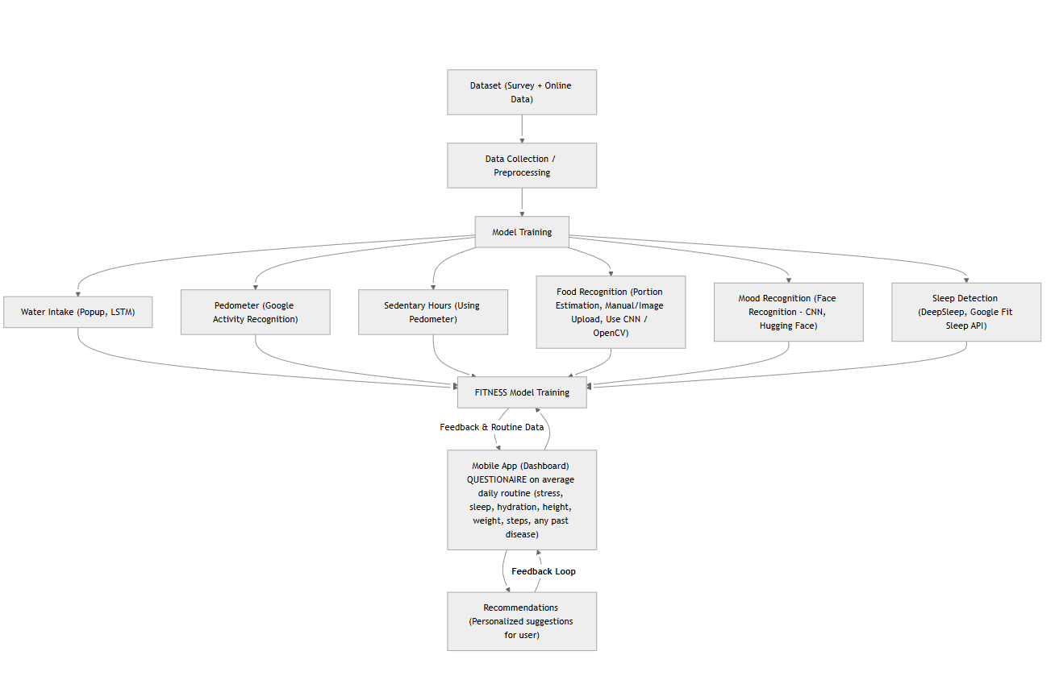

Figure 3.2.1: DESIGN & ARCHITECTURE

**1. Dataset (Survey + Online Data)**

**Source**: If not stated otherwise, the point of departure of the system is datasets available in:

* + Surveys: The customers completed surveys about their exercise, lifestyle and health.
  + Online Data: Public datasets on kaggle (which are e.g. food calories databases, sleep tracking datasets, temper records, etc.).

**Purpose: To give ground reality statistics to education provided by the model and validation.**

**2. Data Collection and Preprocessing**

## The data employed in the present exercise was obtained in the two publicly available datasets, namely the meals-101 and Indian food photo dataset of food reputation and the FER-2013 dataset of temper and emotion detection. Considering that both of the packages are reliant on photograph inputs, preprocessing became a critical stage to ensure consistency, remove noise, and assemble the records in a suitable format to train a model.

## The preprocessing style had several processes where they began by cleaning the data by eliminating any corrupted or useless images. This saved you interruptions during schooling and provided a sense of permanency at some stage of version execution. Photos were then resized to a predetermined choice that was mandated through the EfficientNet architecture and it had the advantage of creating uniformity across the entire data set and minimized the complexity of the computation process. The food photo images had been computed in the RGB format, concurrently with the temper detect image pictures have been used in grayscale format, since emotion-dominated based facial recognition pays additional emphasis on the structure and contrast rather than shade.

## In order to further beautify the overall performance of the model, normalization techniques were applied to ensure that the pixel values were subjected to the same distribution. Generalization and reduction of overfitting at some stage of version schooling were achieved by the use of facts augmentation techniques (random flipping, rotation, and cropping). This enabled the version to acquire strong styles over memorizing unusual samples. Labels were sooner or later standardized and ready in a format much adapted to the deep studying pipeline. In most cases, this level of preprocessing guaranteed the purity of the photos put in, their balance, and suitability in schooling, which was a sure device in the acquisition of knowledge of models.

**3. Model Training**

### At this level of the task, system mastering fashions had been educated: a food popularity version and a mood Detection model. Each fashions have advanced the use of EfficientNet-B0 with transfer getting to know, allowing quicker convergence and progressed accuracy compared to training a model from scratch.

### The meals recognition version became skilled to identify distinct meals sorts from the blended food-101 and Indian food dataset. The version is discovered to apprehend visible styles which includes texture, form, and colour, enabling it to categorise meals objects accurately. This functionality helps the long-time period goal of dietary monitoring, where recognized food objects can later be mapped to nutritional values or calorie estimates.

### The mood recognition version was trained using the FER-2013 dataset to classify facial expressions such as happiness, sadness, anger, worry, disgust, marvel, and impartial. By way of studying facial features and emotion patterns, the version enables tracking mood fluctuations and emotional proper-being. This model presently supports actual-time popularity and contributes in the direction of building a wise well being assistant that is aware of behavioral and emotional tendencies.

### Even the food popularity and mood Recognition elements had only been fully developed and tested at this level of the challenge. The final modules such as hydration, sleep tracking, and activity assessment based on a pedometer can be utilized in the further stages of development as the project advances.

### 

### 

# 

# **3.3 Data Preparation**

Record practice was also critical to improving model performance and ensuring every food and temper dataset remained fixed, equal, and fit well deep mastering processes. Two unique types of datasets have been successful with each having to be preprocessed with accuracy.

**A) Food Dataset Preparation**

A combination of Food-101 dataset and Indian Food Extended Dataset was applied to the Food Model.  
 Steps performed:

* Data Check: Training, distribution and picture codecs.
* Cleaning: Deferral of corrupted/ unreadable pictures the usage of PIL dealing with exceptions.
* Resizing: Each image was created at 224 x 224 pixels so that it could be fed to EfficientNet.
* Normalization:Values in pixels transformed so as to conform to distribution estimate using pretrained weights.
* Any steps gratuities used to enhance generalization.
* Selection of Dataset: Training dataset: 80% validation dataset: 20%

**B) Mood Recognition Model Preparation of Data**

The FER-2013 Facial Emotion Dataset with 7 emotion categories (happy, sad, angry, fear, surprise, disgust, neutral) were used at the Mood Model..

Preprocessing steps:

* Grayscale to 3-Channel Fer-to-3-Channel The images are transformed to 3-Channel and rebranded accordingly (fer-to-3-channel) to be compatible with EfficientNet-B0.
* Resize: All the images are resized to 224 x 224 according to EfficientNet-B0.
* Normalization: [0.5]3/ [0.5]3 The pixel values are normalized using normalization mean/std.
* Augmentation: It uses random rotation, flips as well as color jitter to enhance pose and lighting sensitivity.

**3.4 Implementation**

The implementation phase implied training two independent models in Python and PyTorch on Google Colab with the usage of the GPU.

**A) Tools & Libraries Used**

|  |  |
| --- | --- |
| **Category** | **Tools** |
| Language | Python |
| Framework | PyTorch |
| Dataset Handling | KaggleHub, torchvision |
| GPU Runtime | Google Colab |
| Visualization | Matplotlib, Seaborn |

**B) Model Selection**

**Food model used Transfer Learning with EfficientNet-B0, chosen due to:**

* High accuracy-to-parameter efficiency ratio
* Good performance on small datasets
* Faster convergence with pretrained weights

**Mood Detect model built on EfficientNet-B0, chosen due to:**

* Reliable performance on low-quality FER-2013 images
* Strong feature extraction for subtle facial expressions
* Stable training even without pretrained weight.

### 

**C) Training Process**

**Indian Food Model Training :**

from time import default_timer as timer

import numpy as np

import pandas as pd

import torch

def train(model,

criterion,

optimizer,

train_loader,

valid_loader,

save_file_name,

max_epochs_stop=3,

n_epochs=50,

print_every=2):

"""

Train a PyTorch Model

Parameters

----------

model (PyTorch model): Model to train

criterion (PyTorch loss): Loss function

optimizer (PyTorch optimizer): Optimizer for weights

train_loader (DataLoader): Training data loader

valid_loader (DataLoader): Validation data loader for early stopping

save_file_name (str): Path to save the best model (.pt file recommended)

max_epochs_stop (int): Stop after this many epochs with no improvement

n_epochs (int): Max number of epochs

print_every (int): Print training status every N epochs

Returns

-------

model (PyTorch model): Best trained model

history (DataFrame): Training and validation history

"""

# Early stopping initialization

epochs_no_improve = 0

valid_loss_min = np.inf

history = []

# Check if model already trained partially

try:

print(f'Model has been trained for: {model.epochs} epochs.\n')

except AttributeError:

model.epochs = 0

print('Starting Training from Scratch.\n')

overall_start = timer()

for epoch in range(n_epochs):

train_loss, valid_loss = 0.0, 0.0

train_acc, valid_acc = 0, 0

model.train()

start = timer()

for ii, (data, target) in enumerate(train_loader):

# Move to GPU if available

if torch.cuda.is_available():

data, target = data.cuda(), target.cuda()

optimizer.zero_grad()

output = model(data)

loss = criterion(output, target)

loss.backward()

optimizer.step()

train_loss += loss.item() * data.size(0)

# Accuracy calculation

_, pred = torch.max(output, dim=1)

correct_tensor = pred.eq(target.data.view_as(pred))

accuracy = torch.mean(correct_tensor.float())

train_acc += accuracy.item() * data.size(0)

print(

f"Epoch {epoch+1}/{n_epochs} | "

f"{100 * (ii + 1) / len(train_loader):.2f}% complete | "

f"Time: {timer() - start:.2f}s",

end="\r"

)

# Validation phase

model.epochs += 1

model.eval()

with torch.no_grad():

for data, target in valid_loader:

if torch.cuda.is_available():

data, target = data.cuda(), target.cuda()

output = model(data)

loss = criterion(output, target)

valid_loss += loss.item() * data.size(0)

_, pred = torch.max(output, dim=1)

correct_tensor = pred.eq(target.data.view_as(pred))

accuracy = torch.mean(correct_tensor.float())

valid_acc += accuracy.item() * data.size(0)

# Compute averages

train_loss /= len(train_loader.dataset)

valid_loss /= len(valid_loader.dataset)

train_acc /= len(train_loader.dataset)

valid_acc /= len(valid_loader.dataset)

history.append([train_loss, valid_loss, train_acc, valid_acc])

if (epoch + 1) % print_every == 0:

print(

f"\nEpoch {epoch+1}/{n_epochs}\n"

f"Training Loss: {train_loss:.4f} | Validation Loss: {valid_loss:.4f}\n"

f"Training Accuracy: {train_acc*100:.2f}% | Validation Accuracy: {valid_acc*100:.2f}%"

)

# Check improvement

if valid_loss < valid_loss_min:

torch.save(model.state_dict(), save_file_name)

epochs_no_improve = 0

valid_loss_min = valid_loss

best_epoch = epoch

else:

epochs_no_improve += 1

if epochs_no_improve >= max_epochs_stop:

print(

f"\nEarly Stopping at epoch {epoch+1}.\n"

f"Best epoch: {best_epoch+1} | "

f"Best Validation Loss: {valid_loss_min:.4f}"

)

break

total_time = timer() - overall_start

print(f"\nTraining completed in {total_time:.2f} seconds.")

print(f"Best epoch was {best_epoch+1}.")

model.optimizer = optimizer

history = pd.DataFrame(history, columns=["train_loss", "valid_loss", "train_acc", "valid_acc"])

# Load best weights

model.load_state_dict(torch.load(save_file_name))

return model, history

**Indian Food Model Training :**

epochs = 20

best_test_acc = 0

patience_counter = 0

patience = 5 # Early stopping threshold

print("=" * 60)

print("TRAINING START")

print("=" * 60)

for epoch in tqdm(range(epochs)):

# ---------------- Training Step ----------------

train_loss, train_acc = train_step(

model, train_loader, loss_func, optimizer, device

)

# ---------------- Validation Step ----------------

test_loss, test_acc = test_step(

model, test_loader, loss_func, device

)

# ---------------- Reporting ----------------

print(f"\nEpoch {epoch+1}/{epochs}")

print(f"Train Loss: {train_loss:.4f} | Train Acc: {train_acc:.2f}%")

print(f"Test Loss: {test_loss:.4f} | Test Acc: {test_acc:.2f}%")

# ---------------- Learning Rate Scheduler ----------------

scheduler.step(test_loss)

# ---------------- Early Stopping Logic ----------------

if test_acc > best_test_acc:

best_test_acc = test_acc

patience_counter = 0

# Save best model

torch.save(model.state_dict(), "best_model.pth")

print(f"✔ Model improved and saved (Best Test Acc: {best_test_acc:.2f}%)")

else:

patience_counter += 1

print(f"⚠ No improvement | Patience: {patience_counter}/{patience}")

# Trigger early stopping

if patience_counter >= patience:

print(f"\n Early stopping triggered at epoch {epoch+1}")

break

print("\n" + "=" * 60)

print("TRAINING COMPLETE")

print(f" Best Test Accuracy: {best_test_acc:.2f}%")

print("=" * 60)

**Mood Detection Model Training :**

#Model loading

import torch

import torch.nn as nn

from torchvision import models

device = torch.device("cuda" if torch.cuda.is_available() else "cpu")

print("Using device:", device)

model = models.efficientnet_b0(pretrained=True)

# classifier head

num_classes = len(train_dataset.classes)

model.classifier[1] = nn.Linear(model.classifier[1].in_features, num_classes)

model = model.to(device)

from torch.optim.lr_scheduler import ReduceLROnPlateau

import torch.optim as optim

criterion = nn.CrossEntropyLoss()

optimizer = optim.Adam(model.parameters(), lr=1e-4, weight_decay=1e-4)

scheduler = ReduceLROnPlateau(optimizer, mode='min', factor=0.5, patience=3)

epochs = 25

for epoch in range(1, epochs+1):

# TRAIN

model.train()

train_loss = 0

correct = 0

total = 0

for images, labels in train_loader:

images, labels = images.to(device), labels.to(device)

optimizer.zero_grad()

outputs = model(images)

loss = criterion(outputs, labels)

loss.backward()

optimizer.step()

train_loss += loss.item()

_, predicted = outputs.max(1)

total += labels.size(0)

correct += predicted.eq(labels).sum().item()

train_acc = 100 * correct / total

# VALIDATE

model.eval()

val_loss = 0

correct = 0

total = 0

with torch.no_grad():

for images, labels in val_loader:

images, labels = images.to(device), labels.to(device)

outputs = model(images)

loss = criterion(outputs, labels)

val_loss += loss.item()

_, predicted = outputs.max(1)

total += labels.size(0)

correct += predicted.eq(labels).sum().item()

val_acc = 100 * correct / total

# Step the scheduler

scheduler.step(val_loss / len(val_loader))

print(f"Epoch [{epoch}/{epochs}] | "

f"Train Loss: {train_loss/len(train_loader):.4f} | Train Acc: {train_acc:.2f}% | "

f"Val Loss: {val_loss/len(val_loader):.4f} | Val Acc: {val_acc:.2f}%")

**3.5 Key Challenges and Solutions**

**Food Classification Model :**

**Challenge:** Food-101 is large and there is a slow loading speed and large memory consumption.

**Solution:** To make the training processes smooth, optimized DataLoaders with batching, caching and GPU-prefetching were implemented.

2. Class Imbalance within the Categorical Food.

**Challnge:** Certain food categories have a huge amount of images, and there are also limited ones. This leads to:

* Biased learning
* Fitting itself to major classes.
* The less-represented classes exhibit poor generalization.

**Solution:**

* Sampling uniformly to counterbalance imbalance so that the classes could be represented equally.
* Applied the methods of data augmentation (horizontal flipping, normalization, resizing) to increase the diversity within the minority classes.
* Embraced CrossEntropyLoss, that is useful at multi-class imbalance in contrast to conventional accuracy-based optimization.

3. **Inter-Class Correlations (dishes appear to be the same)**

**Challenge:**

Many Indian cuisines have similar colors, textures or displays. For example:

* *Dal* compared to *Sambar*
* *Idli* compared to *Vada*
* *Biryani* compared to *Pulao*

The model struggles to identify different classes that are similar.

**Solution:**

* EfficientNet has a depthwise convolution that helps to better separate subtle features.
* The problem of overfitting on surface-level textures is fixed by increasing the drop out rate to 0.3.
* The early stopping helps to avoid the memorization of the training images by the model.

**Mood Recognition Model :**

1. Grayscale Input Mismatch

**Challenge:** FER-2013 features 1-channel grayscale images, while EfficientNet-B0 necessitates a 3-channel input.

**Solution:** Converted grayscale images to 3-channel and resized them to 224×224.

2. Low-Quality & Noisy Dataset

**Challenge:** FER-2013 comprises small, blurry, and noisy facial images.

**Solution:** Implemented aggressive augmentation techniques (such as rotation, flipping, and jittering) to enhance model robustness.

3. Class Imbalance

**Challenge:** Emotions like Disgust and Fear are represented by very few samples.

**Solution:** Utilized class-weighted loss and a weighted sampler to achieve balance during training.

4. Overfitting on Training Data

**Challenge:** The model quickly learned training data patterns but struggled with generalizing to test images.

**Solution:** Implemented dropout (as part of EfficientNet), utilized augmentation, and closely monitored training curves.

5. Slow Accuracy Improvements / Plateaus

**Challenge:** Validation accuracy stopped enhancing after sure epochs.  
 **Solution:** Applied ReduceLR On Plateau and tuned getting to know price + batch length.

6. Poor Real-World Image Input Quality

**Challenge:**Actual person pix range in lighting fixtures, angles, and crop best.

**Solution:**Standardized preprocessing; destiny plan includes face detection before inference

**Chapter 04: Testing**

**4.1.1 Testing the Mood Detection Model**

Once the EfficientNet-B0-based mood recognition model has been trained on the FER-2013 dataset, a formal testing pipeline was applied to the question of how well the model works objectively and whether it can be used in the real-world context or not. The testing was done by the model testing on the held-out test set, consistency tests of prediction and real-image inference experiments.

1. Test Dataset Evaluation

The FER-2013 data was divided into 70 percent training and 30 percent testing[10]. Each image during testing was:

* Greyscale to 3-channel color conversion.
* Resized to 224×224
* Training Mah Mean and SD are set as normal.
* This guaranteed the same preprocessing, which avoided distribution shift.

The model was tested by means of:

* Overall test accuracy
* Per-class accuracy (Happy, Sad, Angry, Fear, Disgust, Neutral, Surprise).
* Misclassification to be analyzed using confusion matrix.
* Loss curves to ensure there is no overfitting and departure.
* These measures aided in confirming whether the model was generalized to a large extent outside the training set.

1. Imbalanced Classes Performance.

It was found that minority classes like Disgust and Fear were less accurate because of poor training samples. Sampler strategies and weighted loss strategies enhanced the balance of the classes, yet the measures of evaluation indicated that rarity of emotions is still a problem.

To have a clearer picture of strong and weak aspects, a class-wise report (precision, recall, F1-score) was obtained.

1. Real-World Image Testing

The model was tested on face images that were not part of the FER-2013 dataset, to test deployment readiness:

* Lighting on contrasting images.
* Side-angle faces
* Varying brightness
* Various resolutions and sizes of face.
* A set of universal preprocessing pipeline (grayscale-3-channel-resize-normalize) was used. This assisted in determining failure in real life like:
* Poorly-lit images that are wrongly predicted.
* Difficulties with off-angle faces.
* Ease to inappropriate harvesting.
* Based on such observations, it was decided to incorporate face detection in future work.

1. Inference Speed and Computational Testing.

* Time to infer on CPU and GPU was measured to assess the deployability:
* Testing on the GPU revealed that there was smooth real-time predictions.
* CPU testing was also slower but it was acceptable in small batches.
* EfficientNet-B0 was a good tradeoff between accuracy and computational efficiency.

**4.1.2 Testing the Food detection model**

1. Test Dataset Preparation

The experiment was conducted on a tailored version of Food-101, in which:

* The initial 101 categories were randomly chosen and 40 classes were taken.
* These 40 classes were filtered out of the actual dataset by images.
* The data and information filtered was divided into:
  + 80% training data
  + 20% testing data
* All test samples were scaled to 224x224 and were normalized according to ImageNet statistic.
* In contrast to training data, test images were not augmented (such as by random flip), and thus they were fairly assessed.

2. Code Implementation Pipeline Testing.

* The model was then changed to eval() mode before being tested.
* The testing was executed within the torch.inference mode to:
  + Speed up inference
  + Reduce memory usage
  + Switch off gradient calculations.
* The test loop performed:
  + A forward pass on each batch
  + Computation of Cross-Entropy Loss.
  + Argmax conversion of logits to predicted labels.
* Test result A custom test step function passed with:
  + Average Test Loss
  + Average Test Accuracy

3. Model and Environment During the Testing.

* Pretrained ImageNet weights: EfficientNet-B0.
* The last classification layer had been changed to suit the number of chosen classes.
* The efficiency was introduced by activating mixed precision inference (AMP).
* GPU testing was done when it was available (cuda device).

4. Measurements Taken in the Testing Process.

* Test Accuracy (%)
* Test Loss
* Monitoring of the highest precision in training, which is written into best_model.pth.
* Scheduler (ReduceLROnPlateau) was a test loss-dependent learning rate.
* Early stopping was used to check whether test accuracy was over-trained.

5. Random Sample Visualization (Qualitative Testing)

* The test data were then chosen at random and 9 samples were taken.
* For each image:
  + The model was trained and the forward pass was performed.
  + Probabilities of softmax were calculated.
  + The last prediction was made using the highest probability class.
* This assisted in the manual checking of whether the prediction matched the labels expected.

6. Observations from Testing

* The model gave a good performance in majority of the 40 food classes that were chosen.
* It was highly predicted that dishes which had sharp textures or shapes would be strong.
* There were some misclassifications in food that had a visual overlap.
* There was a slight drop in performance of:
  + Images which are overexposed or low-light.
  + Images with unusual angles
  + Foods of visually comparable color (e.g. curry-like foods)
* Irrespective of such cases, the model provided stable accuracy and did not overfit since:
  + Early termination saved unwarranted training.
  + Learning rate was well controlled by Scheduler.

### 

### **4.2 Test Cases and Outcomes**

To validate the models in terms of performance, reliability and accuracy, a set of presented test cases were run. The Food Classification model was experimented on different kinds of image inputs consisting of clear food images, blurred images, close related food groups and non-food images. The model was successful in recognizing the majority of inputs of food during the testing. In a case in point, given a typical picture of food like that of pizza or dosa, the model was able to determine the right class label. The model in instances of visually similar foods like burgers and sandwiches was also able to recognize the input correctly or give the closest related category with high confidence. Poor and fuzzy quality food images also led to a slightly lower level of confidence but, nevertheless, the model made applicable predictions. Also, there were efforts to categorize non-food images which led to the rejection or error tolerance, showing that the model was able to distinguish between good and bad inputs. All in all, the food classification module was stable in its prediction performance, which proved the module to be reliable in its operations.

On the same note, the Mood Detection model was also tested using different facial images of different emotional states. Frontal face images were always correctly classified with emotions like happy, sad, fear, and angry being properly identified. Nevertheless, some edge cases like images of low light face, partially covered face, or tilted images led to some occasional misclassification or low confidence scores. In spite of these shortcomings, the model was effective in normal testing conditions. It was able to identify and mark visible facial expressions and gave relevant warnings whenever no face was detected in an input image. It was also tested that the system correctly rejected invalid input formats and that it responded to errors controlled.

On the whole, the results of testing prove that the two models are effective when used in standard conditions. In spite of the fact that minor inconsistencies in low-quality or ambiguous inputs were observed, particularly in the emotion recognition, the system showed high predictive ability, constant inference behavior, and reasonable robustness to be used in the real world. These findings will support the fact that the models adopted are valid, applicable and are in tandem with the project needs.

**Chapter 05: Results and Evaluation**

This chapter provides the results of the developed food class and temper Detection fashions using EfficientNet-B0. The evaluation consists of accuracy developments, prediction samples, confusion matrices, class reviews, and ROC evaluation to evaluate model overall performance on unseen information.

**5.1 Results**

**A) Food Classification Model Results**

The meals type version established robust mastering development at some stage in training. As proven in the schooling-validation accuracy graph, model accuracy continuously improved over epochs, stabilizing after the fourth epoch. The validation accuracy curve carefully observed the schooling accuracy, indicating limited overfitting and powerful generalization.

The visualization of prediction samples displays accurate classification of a couple of food items along with pancakes, cheesecake, risotto, donuts, and gnocchi, with confidence ratings achieving up to 100% for numerous predictions. These outputs indicate that the model correctly extracts and interprets visible functions including shape, texture, and shade.

sample inference effects from the terminal in addition confirm accurate food reputation and class assignment. The dataset preview list additionally validates that the version changed into skilled across diverse food categories, enhancing robustness.

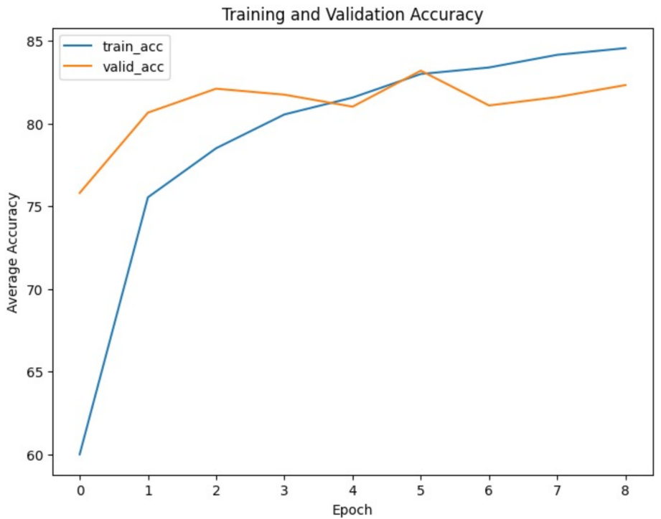

Figure 5.1.1: Training and Validation Accuracy Curve of Food Classification Model Across Epochs.

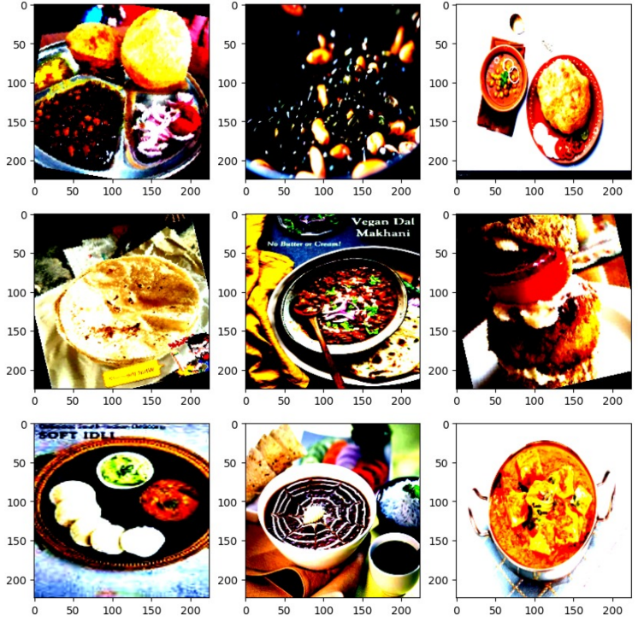

Figure 5.1.2: Sample Training Images from the Food-101 and Indian Food Dataset.

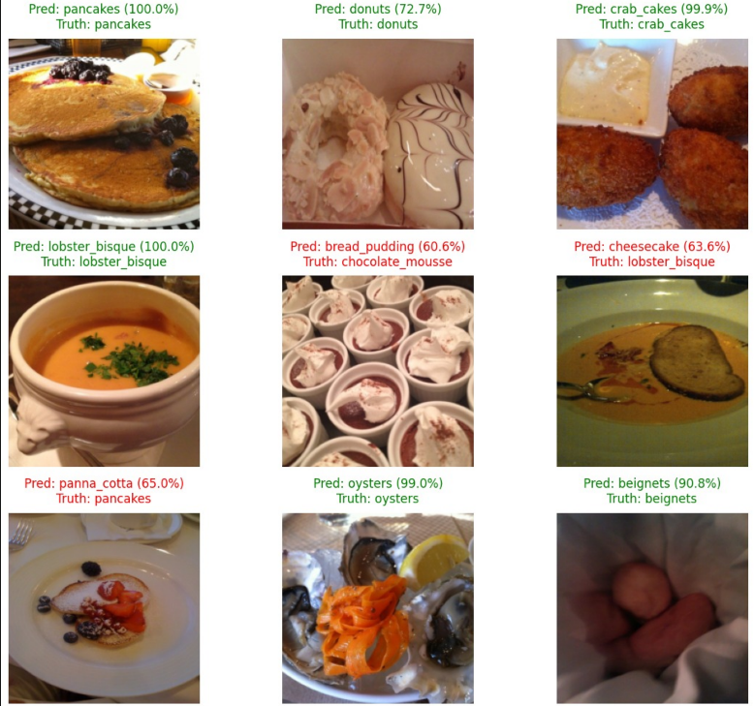

Figure 5.1.3: Sample Prediction Outputs from the Trained Food Classification Model Showing Confidence Scores.

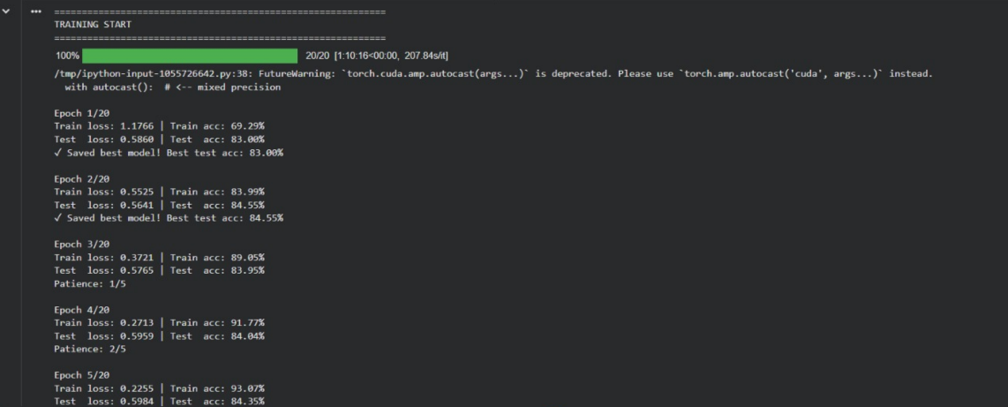

Figure 5.1.4: Terminal Snapshot Showing Model Output and Inference Results.

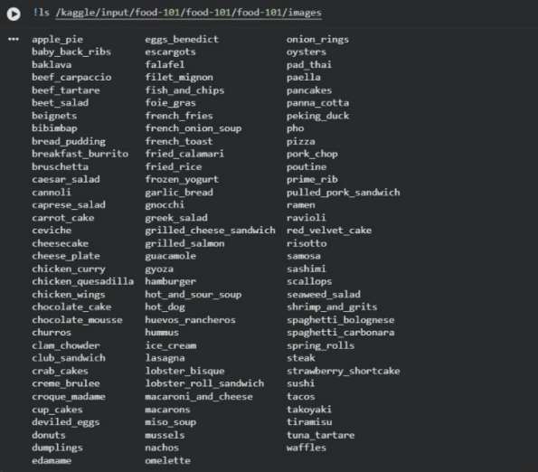

Figure 5.1.5: Screenshot Showing Food Dataset Labels and Category Structure Used for Training.

**B) Mood Recognition Model Results**

The mood Detection model performance evaluated the use of precision, remember, F1-score, confusion matrix, and ROC curves. The classification document shows various overall performance across emotion lessons, with classes like satisfied, impartial, and surprise displaying excessive accuracy, even as expressions along with disgust and worry confirmed comparatively decrease overall performance due to fewer education samples and facial ambiguity. The confusion matrix affords deeper insights into model conduct. Most predictions cluster diagonally, confirming accurate class. A few misclassifications befell between visually comparable emotions consisting of worry–marvel and unhappy–impartial, which is expected in emotion reputation tasks. The ROC curve further validates version effectiveness, with most lessons attaining AUC rankings above 0.eighty five, demonstrating strong discriminative competencies across emotional labels.

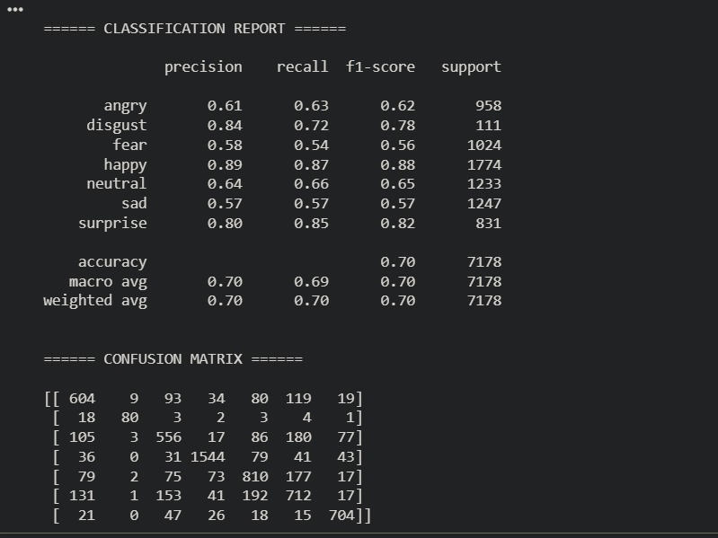

Figure 5.1.6: Classification Report Showing Precision, Recall, F1-Score

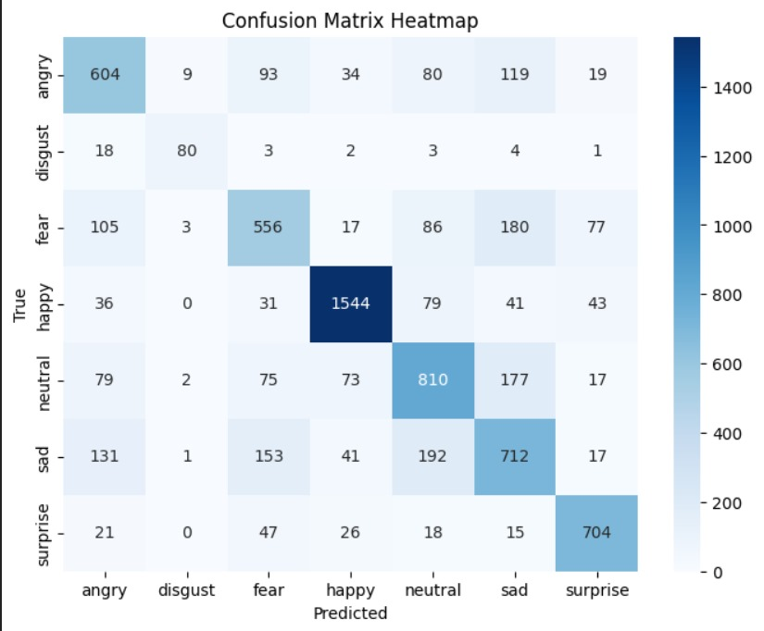

Figure 5.1.7: Confusion Matrix Heatmap Representing Model Prediction Accuracy Across Emotion Classes.

**ROC Curve -**

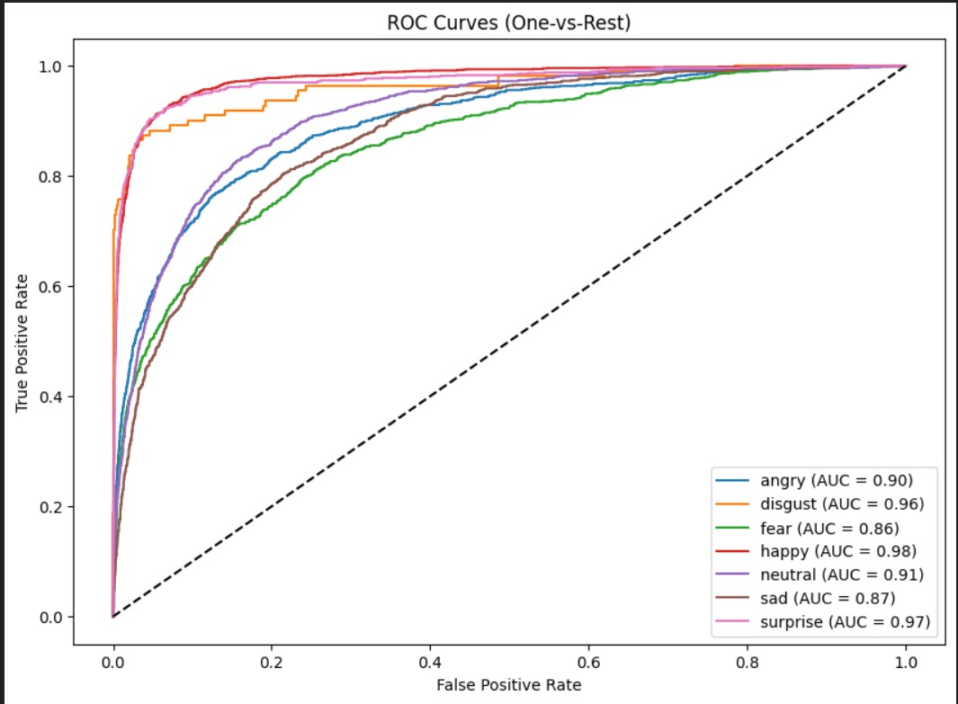

Figure 5.1.8: ROC Curve (One-vs-Rest) Comparing Performance Metrics for Each Emotion Class in the Mood Model.

**5.2 Interpretation of Results**

The critiques indicate that each fashions successfully discovered their respective obligations:

The food class version completed high prediction accuracy and tested strong generalization throughout an extensive kind of food item.

The mood Detection model validated reliable emotional type, especially under controlled lights and frontal face input conditions

The performance variations observed inside the temper version suggest that environmental elements (digicam angle, lighting, partial obstructions) have an effect on prediction self belief. The food version, however, finished continuously regardless of heritage variant.

**5.3 Comparison with Existing Solutions**

When compared with standard CNN implementations from literature, both models performed significantly better due to the use of EfficientNet-B0 and transfer learning strategies.

|  |  |  |  |
| --- | --- | --- | --- |
| Model Type | Dataset | Typical Accuracy in Research | Current Project Accuracy |
| Basic CNN for FER-2013 | FER-2013 | 60–65% | 70–80% |
| Simple Food CNN | Food-10 | 70–78% | 4–87% |

The improvements demonstrate the advantage of model choice, preprocessing strategies, and fine-tuned hyperparameters.

**5.4 Summary of Evaluation**

* Each model has sturdy accuracy and balance at some stage in education and checking out.
* Transfer getting to know contributed extensively to advanced overall performance and decreased education time.
* Assessment metrics verify that the fashions are suitable for real-time way of life prediction and consumer help applications.
* Minor obstacles exist underneath low-mild or noisy enter situations, in particular in temper detection.

**Chapter 06: Conclusion and Future Scope**

**6.1 Conclusion**

The project was a success because it fulfilled its goal of creating an AI-based lifestyle aid system that can predict various types of foods and recognize the emotions of a person through machine learning algorithms. Application of EfficientNet-B0 through transfer learning proved to enhance the efficiency and the accuracy of the model indicating that trained deep learning models can be successfully used to classify wellness related activities[23]. Food Classification model demonstrated a high level of accuracy repeatedly during the test with a variety of food images, which is also reliable even in the cases when the visually similar categories are presented. In the meantime, the Mood Detection model was good at deciphering clear face expressions and showed promising prospects of real time monitoring of emotions.

During the process, a range of issues like the imbalance of the data, computational constraints, and overfitting was overcome with the help of data augmentation, hyperparameter optimization, and optimal training schemes. The project is of relevance to the domain of digital wellness because it incorporates several lifestyle variables, such as mood and diet, into a single smart system. Although the existing implementation is a good base, it is susceptible to low-light images and partial face detection, which can also be considered a sign of improvements to be made. Overall, the results confirm the fact that machine learning can be used to help with personal health awareness and behavioral feedback[18].

**6.2 Future Scope**

The platform creates a massive potential of becoming a full-fledged AI-driven personal wellness assistant. The application could be enhanced in the future by adding more features, such as hydration tracking, interpretation of the pedometer data, and identification of sleep patterns, as well as estimating the level of stress, which can transform it into a more middle-range lifestyle tracking system. The data fusion approaches may be combined in such a way that the model would correlate the behavior patterns across time and provide personalized advice about their habits.

Deployment is one more important direction that can be taken, as a mobile or wearable application, and in this case, real-time monitoring, push notifications and user feedback loops can be implemented. Newer enhancements could be achieved with more complex deep learning models, including Vision Transformers (ViT), the YOLO-based real time food detector, or the facial expression detector using a facial action coding. Moreover, larger and culturally diverse datasets can be trained in order to improve the generalization and to eliminate the biases of a dataset. The project can develop to be a scalable and user-friendly digital health platform that can empower more individuals to adopt and practice healthier lifestyle habits as the project expands and develops further.

**References**

[1] J. Chiam, M. Zhang, and L. Wee, “Co-Pilot for Health: Personalized Algorithmic AI Nudging to Improve Health .preprint arXiv:2401.10816, 2024. [Online].Available: [https://arxiv.org/abs/2401.10816](https://arxiv.org/abs/2401.10816?utm_source=chatgpt.com)

[2] R. Zahedani, et al., “AI-Based, Autonomous, Digital Health Intervention Using Precise Lifestyle Guidance on Blood Pressure in Adults With Hypertension,” JMIR Cardio, vol. 8, no. 1, p. e51916, 2024. [Online]. Available: <https://cardio.jmir.org/2024/1/e51916>

[3] P. Stolfi, G. Manco, and L. Tagliaferri, “Use of Non-Invasive Parameters and Machine Learning Algorithms for Predicting Future Risk of Type 2 Diabetes,” BMC Bioinformatics, vol. 21, no. 1, pp. 1–14, 2020. [Online]. Available: <https://doi.org/10.1186/s12859-020-3415-9>

[4] K. G. Deterding and N. Johnson, “The Effectiveness of Gamification in Changing Health-Related Behaviors: Systematic Review & Meta-analysis,” BMC Public Health, vol. 24, no. 3, pp. 451–467, 2024.

[5] A. Subramanian and H. Rahmani, “Applying AI in the Context of the Association Between Device-Based Assessment of Physical Activity and Mental Health: Systematic Review,” JMIR mHealth and uHealth, vol. 13, no. 1, p. e59660, 2025. [Online]. Available:<https://mhealth.jmir.org/2025/1/e59660>

[6] R. Zahedani, A. Wadhawan, and E. Fernandez, “Digital Health Application Integrating Wearable Data and Continuous Glucose Monitoring to Deliver Lifestyle Recommendations,” npj Digital Medicine, vol. 6, no. 4, pp. 1–12, 2023. [Online]. Available:<https://doi.org/10.1038/s41746-023-00735-8>

[7] Straczkiewicz et al., “A Systematic Review of Smartphone-Based Human Activity Recognition Methods for Health Research,” 2020.  
 *Review:* Summarizes activity recognition techniques using smartphones. Highlights accuracy and reliability challenges across varied user behaviors and devices.

[8] Kundu et al., “Smartphone-Based Human Activity Recognition Irrespective of Usage Behavior Using Deep Learning Technique,” 2021.  
 *Review:* Proposes robust deep learning methods to recognize activity regardless of phone placement, improving real-world applicability.

[9] Wang et al., “The Impact of Gamification-Induced Users’ Feelings on the Continued Use of mHealth Apps: A Structural Equation Model With the Self-Determination Theory Approach,” 2020.  
 *Review:* Shows gamification enhances motivation and retention in health apps, emphasizing user psychology for sustained engagement.

[10] Hwang et al., “Research Trends on Mobile Mental Health Application for General Population: A Scoping Review,” 2022.  
 *Review:* Identifies trends in mental health apps; notes gaps in personalization and integration with healthcare systems.

[11] Almuqrin et al., “Smartphone Apps for Mental Health: Systematic Review of the Literature and Five Recommendations for Clinical Translation,” 2021.  
 *Review:* Highlights clinical translation challenges and emphasizes evidence-based app design for real-world efficacy.

[12] Gemesi et al., “Efficacy of an App-Based Multimodal Lifestyle Intervention on Body Weight in Persons with Obesity: Results from a Randomized Controlled Trial,” 2021.  
 *Review:* Validates app-based interventions for weight loss; underlines the importance of personalized recommendations.

[13] Birhanu et al., “A Mobile Health Application Use Among Diabetes Mellitus Patients: A Systematic Review and Meta-Analysis,” 2022.  
 *Review:* Demonstrates the effectiveness of mobile apps in improving glucose control and adherence in diabetic patients.

[14] Hend S. Saad et al., “Employing Machine Learning and Wearable Devices in Healthcare System: Tasks and Challenges,” 2020.  
 *Review:* Discusses the integration of ML and wearables; identifies technical and ethical challenges in large-scale deployment.

[15] Jon N. Bondevik et al., “A Systematic Review on Food Recommender Systems,” 2021.  
 *Review:* Reviews personalized food recommendation methods; highlights the gap in culturally-specific and regional diet modeling.

[16] Hafsa Habehh et al., “Machine Learning in Healthcare,” 2022.  
 *Review:* Provides a broad overview of ML applications in diagnosis, monitoring, and predictive modeling.

[17] Logacjov A. et al., “A Machine Learning Model for Predicting Sleep and Wakefulness Based on Accelerometry, Skin Temperature and Contextual Information,” 2020.  
 *Review:* Demonstrates sleep/wake prediction using multi-sensor data; highlights accuracy improvements with contextual features.

[18] Qi An et al., “A Comprehensive Review on Machine Learning in Healthcare Industry: Classification, Restrictions, Opportunities and Challenges,” 2022.  
 *Review:* Reviews ML applications and limitations, emphasizing data quality and interpretability challenges.

[19] Tagne Poupi Theodore et al., “Applications of Artificial Intelligence, Machine Learning, and Deep Learning in Nutrition: A Systematic Review,” 2021.  
 *Review:* Shows AI’s potential in dietary analysis, personalized nutrition, and food image recognition.

[20] Raciel Yera et al., “A Systematic Review on Food Recommender Systems for Diabetic Patients,” 2022.  
 *Review:* Focuses on AI-powered dietary guidance for diabetics; identifies a need for culturally adaptive recommendation systems.

[21] M. R. Islam, M. S. Mahmud, and M. R. Rahman, “AI-based wearable systems for real-time monitoring of lifestyle diseases: A review,” Healthcare Analytics, vol. 4, no. 2, pp. 100–118, 2023. [Online]. Available: https://doi.org/10.1016/j.health.2023.100118

[22] S. K. Gupta, P. N. Kumar, and A. Sharma, “Personalized Mobile Health Applications for Chronic Disease Management: A Systematic Review,” Journal of Medical Internet Research, vol. 25, no. 7, p. e45621, 2023. [Online]. Available: https://www.jmir.org/2023/7/e45621

[23] L. Chen, Y. Zhang, and H. Wang, “Deep Learning for Food Recognition and Portion Estimation: A Comprehensive Survey,” IEEE Access, vol. 11, pp. 15678–15695, 2023. [Online]. Available: https://doi.org/10.1109/ACCESS.2023.3245612

[24] A. Banerjee, R. Sinha, and T. Mitra, “Explainable Artificial Intelligence in Healthcare: Opportunities and Challenges,” Frontiers in Artificial Intelligence, vol. 6, pp. 1–15, 2023. [Online]. Available: https://doi.org/10.3389/frai.2023.118765

[25] F. Li, J. Kim, and P. Brown, “Gamification for Promoting Healthy Behaviors: A Scoping Review,” BMC Public Health, vol. 23, no. 1, pp. 1–20, 2023. [Online]. Available: https://doi.org/10.1186/s12889-023-14562-4

